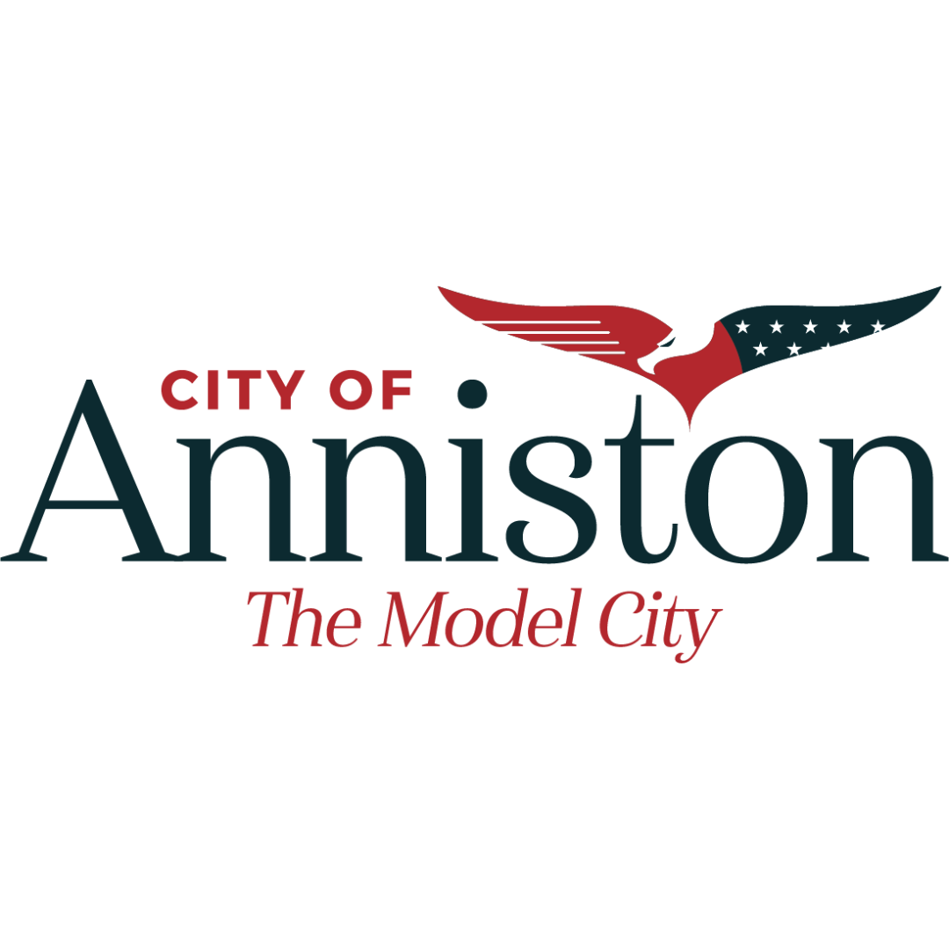

**Privacy Policy for Anniston Parks and Recreation App**

***Last Updated: December 12, 2024***

The Anniston Parks and Recreation App (“the App”) is designed to provide citizens of Anniston, Alabama, with a seamless platform to register for sports, pay online, and enroll in classes at community centers. The City of Anniston values your privacy and is committed to protecting your personal information. This Privacy Policy outlines how we collect, use, and share user data, and how we ensure transparency and compliance with privacy regulations.

**1. Information We Collect**

We may collect the following types of information when you use the App:

• Personal Information

• Name

• Contact information (e.g., email address, phone number)

• Payment information (e.g., credit/debit card details for online payments)

• Date of birth (for child registration)

• Emergency contact details (for sports and activities involving minors)

• Device Information

• Device type, operating system, and app usage data.

• Activity Data

• Registration history for classes, sports, and events.

• Payment transaction details.

**2. How We Use Your Information**

We use your information to:

• Facilitate registrations for sports and classes.

• Process payments securely.

• Communicate confirmations, reminders, and updates related to your activities.

• Improve App functionality and user experience.

• Comply with legal obligations and protect the safety of all users.

**3. How We Share Your Information**

Your data is only shared with authorized entities under the following circumstances:

* Service Providers: Trusted third-party payment processors for secure transactions.
* Law Enforcement: If required by law, we may disclose information to comply with legal processes.
* City Departments: Relevant city departments may access necessary data to administer services.
* We do not sell, rent, or lease your personal information to third parties.

**4. Does the App Contain Ads?**

The Anniston Parks and Recreation App does NOT contain ads of any kind. There are no banner ads, interstitial ads, or native ads displayed within the App.

**5. Data Security**

We prioritize the security of your personal information by implementing:

• Encrypted data transmission (e.g., SSL for payments).

• Regular monitoring of the App for vulnerabilities.

• Limited access to sensitive data by authorized personnel only.

**6. Your Rights**

As a user of the App, you have the right to:

• Access the information we collect about you.

• Request corrections or updates to your personal data.

• Request the deletion of your data, subject to legal and operational obligations.

To exercise these rights, contact us at [Insert Contact Email].

**7. Third-Party Links and Services**

The App may include links to third-party websites for payment processing or additional information. We are not responsible for the privacy practices of these external websites. Please review their privacy policies before providing your information.

**8. Children’s Privacy**

We comply with the Children’s Online Privacy Protection Act (COPPA). Any information collected for minors, such as registration for sports activities, is provided by a parent or guardian.

**9. Privacy Policy Updates**

We may update this Privacy Policy to reflect changes in our practices or for other operational, legal, or regulatory reasons. All updates will be available within the App and on our official website.

**10. Contact Us**

For questions or concerns about this Privacy Policy or the App, please contact us:

City of Anniston Parks and Recreation Department

Email: [fburroughs@annistonal.gov](mailto:fburroughs@annistonal.gov)

Phone: 256-236-8221

***The privacy policy will be accessible on the App’s store listing and within the App at any time.***