
June 23, 2025
2018-2022
CONSOLIDATED PLAN
&
2021
ANNUAL ACTION PLAN AMENDMENT 1

HOME-ARP ALLOCATION PLAN

CITY OF ANNISTON, ALABAMA
City of Anniston
Community Development Department
4309 McClellan Blvd
Anniston, AL 36206

Table of Contents
Introduction 3
Consultation 3
Agencies/Organizations Consulted 4
Public Participation 8
Needs Assessment and Gaps Analysis 9
Homeless Populations 13
Individuals and Families at Risk of Homelessness 13
Fleeing or attempting to flee domestic violence or human trafficking 14
Residents living in housing instability or in unstable housing situations 14
HOME-ARP Activities 17
Use of HOME-ARP Funding 18
HOME-ARP Production Housing Goals 19
Preferences 19
HOME-ARP Refinancing Guidelines 22
PUBLIC NOTICES & PUBLIC HEARING 22
CERTIFICATIONS 29

Participating Jurisdiction: City of Anniston, AL Date: June 23, 2025

Introduction
On May 28, 2025, the City of Anniston Community Development Department was notified by HUD of an administrative error in the allocations of the HOME-ARP funds. This error resulted in the City inadvertently being allocated less HOME-ARP funds than it was legally entitled to receive. As such, the City was allocated an additional $1,643.00 in HOME-ARP funds.

In September 2021, the U.S. Department of Housing and Urban Development announced the allocation of $1,454,489.00 million to the City of Anniston for a new grant called the Home Investment Partnerships Grant American Relief Plan (HOME-ARP). The purpose of HOME-ARP funds is to provide homelessness assistance and supportive services through several eligible activities. Eligible activities include acquisition and development of non-congregate shelter, tenant based rental assistance, supportive services, HOME-ARP rental housing, administration and planning, and nonprofit operating and capacity-building assistance. A certain portion of HOME-ARP funds must assist people in HOME-ARP "qualifying populations,” which include:

- Sheltered and unsheltered homeless populations
- Those currently housed populations at risk of homelessness
- Those fleeing or attempting to flee domestic violence or human trafficking
- Other families requiring services or housing assistance or to prevent homelessness
- Those at greatest risk of housing instability or in unstable housing situations

To receive funding, the City of Anniston Consortium must develop and submit to HUD a HOME-ARP Allocation Plan, which describes the distribution of HOME-ARP funds and identifies any preferences for eligible activities. The development of the HOME-ARP Allocation Plan must also be informed through stakeholder consultation and community engagement. The following is the HOME-ARP Allocation Plan.

Consultation
Summarize the consultation process.

The City of Anniston Consortium partners with public and private entities, which several were consulted with during the development of the HOME-ARP Allocation Plan. These consulted stakeholders have relevant knowledge that can speak to the needs, service gaps, and potential activities that would best benefit qualified populations. Stakeholders consulted included those who work with families or individuals experiencing or at-risk of homelessness, fleeing domestic violence, and other vulnerable qualifying populations.

In the development of the allocation plan, the City consulted with stakeholders and asked for their input concerning the HOME-ARP grant, eligible activities, and the proposed budget. Stakeholders articulated their gap in services and/housing needs by providing written and verbal input. The City has synthesized feedback from participants and the following table will provide summaries of the feedback received. The City will continue to meet with stakeholders throughout the implementation of the HOME-ARP activities to assess the ongoing needs of stakeholders’ clients. The City will also strive to collaborate with stakeholders to develop and effectuate strategies that will help end chronic homelessness.

Agencies/Organizations Consulted
List the organizations consulted, and summarize the feedback received from these entities.

Agencies/Organizations Consulted | Type of Agency/Organizations | Method of Consultation | Feedback | Service Areas
City of Anniston HOME Consortia | Public Agencies that address needs of QP - Affordable Housing | Needs Assessment Interview | Affordable housing has been a need in Anniston as well as locating qualified developers. | Serves the City of Anniston and all of Calhoun County, including City of Piedmont, City of Weaver, City of Jacksonville, and Hobson City
Habitat for Humanity | Public Agencies that address needs of QP - Affordable Housing | Needs Assessment Interview | Need housing for seniors and aging housing stock, aging in place. Affordable housing in a high need and transitional housing. Tiny homes or cottages would be helpful. | Serving Anniston and Calhoun County, including City of Piedmont, City of Weaver, City of Jacksonville, and Hobson City
Alabama Disabilities Advocacy Program | Disability Groups | Needs Assessment Interview | Services for disabled persons in Anniston is critical as well as affordable housing. | Serves City of Anniston and all of Calhoun County, including City of Piedmont, City of Weaver, City of Jacksonville, and Hobson City
The Arc of Calhoun & Cleburne Counties | Disability Groups | Needs Assessment Interview | Need more critical funding for supportive services for transportation, gaps in funding for job training to persons with disabilities, lack of access to information for persons with disabilities. Participants may not be able to read and write and there is a need for more video productions of information. | Serving Anniston and Calhoun County, including City of Piedmont, City of Weaver, City of Jacksonville, and Hobson City & Cleburne County
2nd Chance, Inc. | Domestic Violence Providers | Needs Assessment Interview | Needs more affordable units, and survivors need more resources for budgeting income, life skills, and parenting classes. Substance abuse and low-paying jobs are the largest contributors to housing instability. | Serves the City of Anniston and Calhoun County, including City of Piedmont, City of Weaver, City of Jacksonville, and Hobson City, Cherokee, Cleburne, Etowah, Randolph, and Talladega Counties in Northeast Alabama
Fair Housing Center of Northern Alabama (FHCNA) | Fair Housing/Civil Rights | Needs Assessment Interview | There has been an influx of client issues related to unemployment, housing issues, public benefits, and domestic violence during the pandemic. | Serves City of Anniston and all of Calhoun County, including City of Piedmont, City of Weaver, City of Jacksonville, and Hobson City
Interfaith Ministries | Homeless Service Providers | Needs Assessment Interview | Rental assistance is a high need and affordable units. | Serving Anniston and Calhoun County, including City of Piedmont, City of Weaver, City of Jacksonville, and Hobson City
Anniston Homeless Task Force - Anniston First United Methodist Church  United Way of East Central Alabama | Public Agencies that address needs of QP -Homeless Planning Agency | Needs Assessment Interview | Emergency housing solutions for the unsheltered is a critical need in the community. Developing long-term solutions for the unsheltered is important. | City of Anniston
Salvation Army | Homeless Service Providers | Needs Assessment Interview | Service gaps in bed available for homeless and supportive services. | Serving Anniston and Calhoun County, including City of Piedmont, City of Weaver, City of Jacksonville, and Hobson City
The Right Place | Homeless Service Providers | Needs Assessment Interview | Affordable Income-based housing and shelter: Service gaps in Calhoun County include a shortage of affordable income-based housing and no shelter causing many low-income families to face eviction and struggle with homelessness. With no shelter, which causes them to remain on the street.; Income-based housing, supportive services, and shelter would best benefit qualifying populations. | Consortia
Homeless Coalition of Northeast Alabama - Gadsden/Northeast Alabama COC | Homeless Service Providers | Needs Assessment Interview | Service gaps in bed available for homeless and supportive services. | Serves Anniston, Calhoun County, Cherokee County, Gadsden, Etowah County, Cherokee County, and Dekalb County
All Saints Interfaith Center for Concern | Homeless Services Provider/Disabled Persons | Needs Assessment Interview | Need more homeless support services. Service gaps in limited resources in education and job placement services. | City Anniston and Calhoun County
Community Enabler | Homeless Services Provider/Disabled Persons | Needs Assessment Interview | Need more funding for rental assistance, Service gap: limited funding. Need more assistance for persons experiencing homeless. | City Anniston and Calhoun County
Town of Hobson City Housing Authority | Public Housing Agency |  | The Town of Hobson City Housing Authority has 60 public housing units with no vacancies. States the area needs more affordable units, particularly for large families. Also needs more two bedroom-units. There is a need for more project-based funding. Housing conditions are terrible but there are no codes established to support condemnation of the units. The City needs more Section 8 Vouchers. | Town of Hobson City, City of Anniston, and Oxford
Piedmont Housing Authority | Public Housing Agency | Needs Assessment Interview | The Piedmont Housing Authority has 210 public housing units for the elderly, low-income, and disabled. There are not many jobs around town that pay high wages. Rent costs are increasing, and more affordable housing units are needed. Generational poverty contributes to housing issues in the area. More rental and utility assistance is needed to assist families with permanent housing. | City of Piedmont
Jacksonville Housing Authority | Public Housing Agency | Needs Assessment Interview | The Jacksonville Housing Authority has 175 units of public housing, of which 48 are multifamily units for the elderly and disabled and 14 for mental health clients. The city is a college town and experienced a tornado in 2017 that damaged student housing. Coupled with rising housing costs and student displacement into the private sector, housing affordability and availability are at an all-time high. There are no shelters in the area and some families are experiencing homelessness for the first time. People in this area need more rent and utility assistance, especially security deposits. | City of Jacksonville
Anniston Housing Authority | Public Housing Agency | Needs Assessment Interview | The public housing stock is decreasing due to property age and the need for repair, with very little redevelopment due to funding allocations. Service gaps: Affordable Housing Potential activities to benefit qualified populations: Affordable Housing to decrease homelessness. | City of Anniston
Disabled American Veterans | Veteran Groups | Needs Assessment Interview | Need more funds allocated for assisting Veterans with access to services and affordable housing for Veterans. | Serving Anniston and Calhoun County, including the City of Piedmont, the City of Weaver, City of Jacksonville, and Hobson City
Veterans Helping Veterans Foundation, Inc | Veteran Groups | Needs Assessment Interview | Mental health resources are needed for veterans not declared 100% disabled. Mental illness could lead to veteran homelessness. | Serving Anniston and Calhoun County, including City of Piedmont, City of Weaver, City of Jacksonville, and Hobson City
Jacksonville Christian Outreach Center | Public Agencies that address needs of QP | Needs Assessment Interview | Provides a food pantry, utility assistance, and baby essentials. The agency offers utility assistance for families that have fallen behind on utilities but has seen an increase in the need for families needing security deposits. | City of Jacksonville
Table 1: Agencies/Organizations Consulted

Public Participation

Describe the public participation process, including information about and the dates of the public comment period and public hearing(s) held during the development of the plan:

Initial
- Public comment period: January 18, 2023 – February 3, 2023
- Public hearings: December 9, 2022, and January 19, 2023
Subsequent Amendments
- Public comment period: July 2, 2025 – July 18, 2025
- Public hearings: July, 3, 2025

The City held two public hearing for the consultation with citizens, municipal officials, non-profit agencies, public housing agencies, private developers, governmental agencies, and the Continuum of Care in preparation for the HOME-ARP Allocation Plan. The City held an additional public hearing on July 3, 2025 for the increased allocations.

During the public hearing, City staff discussed the development of the HOME-ARP Allocation Plan, which incorporated information and discussion of community needs and eligible activities related to HOME-ARP, along with an opportunity for the public to provide comments on the proposed budget and activities. list of eligible HOME-ARP activities and the City’s proposed HOME-ARP budget was also presented. The public hearing was held on December 9, 2022, and January 19, 2023.

The public notice for the HOME-ARP Allocation Plan was published on the City’s website on Wednesday, January 18, 2023, in English & Spanish. The public comment period on the Draft HOME-ARP Allocation Plan coincided with the public hearing, beginning January 18, 2023, and ending on February 3, 2023.

The public notice for the Amendment to the HOME-ARP Allocation Plan was published on the City’s website on Wednesday, July 2, 2025, in English & Spanish. The public comment period on the Draft HOME-ARP Allocation Plan coincided with the public hearing, beginning July 2, 2025 and ending on July 18, 2025.

Describe any efforts to broaden public participation:
To increase public participation, the City actively maintains communication with local nonprofits and housing developers and will adhere to the following actions to improve citizen participation:

Actions to improve participation

- Conduct public meetings in various communities throughout the City to ensure that meetings are held at a convenient location for residents of the City and/or virtually.
- Conduct workshops at various locations throughout the City; provide ADA accessibility for all persons with disabilities; and provide interpretation for limited English proficiency clientele.
- Use electronic and print media to solicit public participation through various media outlets. This includes sending mass emails to City employees, nonprofit organizations, and local businesses; and posting information on the City’s Community Development website.

- Translate public notices and related materials for limited English proficiency clientele.
- Review and respond to all citizen comments and incorporate such comments in the Action Plan, as applicable.
- Analyze the impact of Action Plan program activities on neighborhood residents, particularly low and moderate-income persons.
- Accepts any comments or views of residents received in writing, or orally at a public hearing, during the preparation of the HOME-ARP allocation plan.

Summarize the comments and recommendations received through the public participation process:
Needs highlighted during the Needs Assessment:
- Lack of affordable housing
- Aging stock of available housing
- Need more funding for supportive services and case management
- Limited resources
- Need more homeless beds and services
- High Rental Rates
- Lack of access to supportive services
- Overcrowding & Cost Burdens

Summarize any comments or recommendations not accepted and state the reasons why:
All comments were accepted.

Needs Assessment and Gaps Analysis

To assess the unmet needs of HOME-ARP qualifying populations, the City evaluated the size and demographic composition of those populations. In addition, the City also identified gaps within its current shelter and housing inventory, as well as the service delivery system. In the needs assessment and gaps analysis, utilized current data, including Comprehensive Housing Affordability Data (CHAS), 2021 Point in Time Count (PIT Count), 2021 CoC Housing Inventory Count (HIC), or other data available data sources. The following information includes the basis for the Needs Assessment and gap analysis for HOME-ARP qualified populations.

Homeless Needs Inventory and Gap Analysis Table
Homeless
 | Current Inventory |  |  |  |  | Homeless Population |  |  |  | Gap Analysis
 | Family |  | Adults Only |  | Vets | Family HH (at least 1 child) | Adult HH (w/o child) | Vets | Victims of DV | Family |  | Adults Only
 | # of Beds | # of Units | # of Beds | # of Units | # of Beds |  |  |  |  | # of Beds | # of Units | # of Beds | # of Units
Emergency Shelter | 29 | 13 | 86 | 0 | 0
Transitional Housing | 4 | 4 | 13 | 0 | 0
Permanent Supportive Housing | 5 | 2 | 45 | 0 | 0
Other Permanent Housing |  |  |  |  |  | 2 | 5
Sheltered Homeless |  |  |  |  |  | 6 | 47 | 0 | 12
Unsheltered Homeless |  |  |  |  |  | 3 | 171 | 13 | 14
Current Gap |  |  |  |  |  |  |  |  |  | 11 | 223 | 13 | 26
Data Sources: 1. Gadsden/Northeast Alabama COC 2021 Point in Time Count (PIT); 2. Gadsden/Northeast Alabama Continuum of Care Housing Inventory Count (HIC). Table 2: Homeless Needs Inventory and Gap Analysis Table

Housing Needs Inventory and Gap Analysis Table
Non-Homeless
 | Current Inventory | Level of Need | Gap Analysis
 | # of Units | # of Households | # of Households
Total Rental Units | 11,172 | 5,707 | -5,465
Rental Units Affordable to HH at 30% AMI (At-Risk of Homelessness) |  | 1,030
Rental Units Affordable to HH at 50% AMI (Other Populations) |  | 1,972
0%-30% AMI Renter HH w/ 1 or more severe housing problems (At-Risk of Homelessness) |  | 1,780
30%-50% AMI Renter HH w/ 1 or more severe housing problems (Other Populations) |  | 925
Current Gaps |  |  | -5,465
Data Sources: 1. American Community Survey (ACS); 2. Comprehensive Housing Affordability Strategy (CHAS); National Low Income Housing Coalition Out of Reach Report 2021: Anniston Alabama
Table 3: Housing Needs Inventory and Gap Analysis Table
The supply of rentals has increased between 2010 and 2019 by a little over 2,500 units. There were 8,641 occupied units paying rent in 2010 and 11,172 occupied units paying rent in 2019. The median monthly rent in 2010 was $586 and increased to $627 per month in 2019. The National Low Income Housing Coalition’s “Out of Reach” 2021 Annual Report calculates the amount of money a household must earn to afford a rental unit based on the number of bedrooms in a rental unit at the Fair Market Rent (FMR), consistent with HUD’s affordability standard of paying no more than 30% of income for housing costs. Data is presented in the Renter Affordability table for the Anniston-Oxford Jacksonville Metro Statistical Area (MSA).

As noted in the 2021 Out of Reach Report, the NLIHC estimates that the median income for a renter in the Anniston-Oxford Jacksonville MSA is $29,590. The Area’s Fair Market Rent (FMR) for a two-bedroom apartment is $723 and to afford this level of rent and utilities, without paying more than 30% of income on housing. To afford a two-bedroom housing unit without spending more than 30 percent of one’s income on rent, one would need to work at a minimum of 77 hours per week or maintain at least 1.4 full-time jobs in the City.

Describe the size and demographic composition of qualifying populations within the PJ’s boundaries:
HUD requires HOME-ARP funds be used to primarily benefit individuals and families in specified HOME-ARP “qualifying populations.” Qualifying populations include, but are not limited to, the following:
- Sheltered and unsheltered homeless populations
- Those currently housed populations at risk of homelessness
- Those fleeing or attempting to flee domestic violence or human trafficking
- Other families requiring services or housing assistance or to prevent homelessness
- Those at greatest risk of housing instability or in unstable housing situations

Homeless Populations
In accordance with HUD’s definition of homeless under the HOME-ARP grant, the City will consider a homeless family or individual to generally include:
- An individual or family who lacks a permanent and adequate permanent home
- A person or family who will imminently lose their permanent home due to a lack of resources or support
- A youth under the age of 25, even if accompanied by an adult, who does not have a permanent home

The City coordinates integrated grant funded programs with mainstream services for which persons that are homeless or at-risk of homelessness may be eligible. Mainstream services include housing programs, health programs, social services, employment programs, education programs and youth programs. Employment programs are a pivotal part in self-sufficiency and long-term housing sustainability. Shelters and human service providers are limited in their capacity to resolve the problem of homelessness unless due to the multiple issues of causation and the amount of funding available.

Individuals and Families at Risk of Homelessness
HUD defines those at risk of homelessness as individuals and families who have an income below 30% of the area median income (AMI), do not have sufficient resources or support networks to prevent them from becoming homeless, or live with instability, like moving two or more times during the last 60 days due to economic reasons.

Using HUD's 2014-2018 CHAS data, the City of Anniston has 1,635 households with incomes at or below 30% AMI, which is 5% of total households. Almost all households with incomes at or below 30% AMI are renter households. As shown in Table 3 above, there are approximately 1,030 renter households that earn 30% AMI or under and have one or more housing problems, which could include housing cost burden, overcrowding, lack of kitchen facilities, or lack of plumbing facilities. These households are at risk of becoming homeless.

Fleeing or attempting to flee domestic violence or human trafficking
For HOME-ARP, this population includes any individual or family who is fleeing, or is attempting to flee, domestic violence, dating violence, sexual assault, stalking, or human trafficking. It includes cases where an individual or family reasonably believes that there is a threat of imminent harm from further violence due to dangerous or life-threatening conditions that relate to violence against the individual or a family member, including a child, that has either taken place within the individual’s or family’s primary nighttime residence or has made the individual or family afraid to return or remain within the same dwelling unit. There are currently 1 domestic violence and abuse shelters program in Anniston, AL with 1 offering a hotline and 1 offering emergency shelter. Outside of this city and still nearby, residents can also find help at these 5 domestic violence and abuse shelters and programs in places like Oxford, Cedartown, and Carrollton.

Residents living in housing instability or in unstable housing situations
HOME-ARP qualifying populations also include other populations who have previously qualified as homeless, are currently housed with temporary or emergency assistance, and who need additional housing assistance or supportive services to avoid a return to homelessness. In addition, HUD defines those at greatest risk of housing instability as households that have an annual income less than 30% AMI and are experiencing severe cost burden or have an income less than 50% AMI and meet a certain condition, like living in someone else’s home or living in a hotel due to an economic hardship.

Many renters in the City experience varied housing challenges. A total of 41.1% of all renters have housing problems or severe housing problems. In CHAS data, HUD defines housing problems as a household that has one or more of the following: lacking a kitchen or plumbing, having more than one person per room, or being housing cost burdened at 30% of more. Of these problems, housing costs negatively impact most renters whose household income is at or below 50% AMI.

The Alabama Housing Finance Authority’s Emergency Rental Assistance Program launched in February 2021 and as of December 30, 2022, was accepting applications for assistance to receive rent assistance because they were financial impacted by the COVID-19 pandemic, experienced housing instability, and whose household income was at or below 80% AMI. This shows the extreme additional need in Alabama for rental assistance and wrap around or supportive services to assist households who are living in housing instability or that have recently received housing assistance due to COVID-19 impacts.

Describe the unmet housing and service needs of qualifying populations, including but not limited to:
- Sheltered and unsheltered homeless populations.
- Those currently housed populations at risk of homelessness.
- Other families requiring services or housing assistance or to prevent homelessness; and,
- Those at greatest risk of housing instability or in unstable housing situations:

Many of the needs of the qualifying populations are similar and include the need for a flexible response system, available housing that is affordable, wrap around services, and supportive services or assistance that could prevent homelessness or greater housing instability. The following reviews the needs of each qualifying population.

Homeless Populations
People experiencing unsheltered homelessness are at great risk of continued harm due to higher rates of morbidity and mortality resulting from pre-existing health conditions, exposure to the elements, lack of access to healthcare, and elevated rates of hospitalizations with longer, mor complex hospital stays. Long periods of living without shelter also put individuals at a greater risk of social isolation and the chance of victimization. The process of resolving unsheltered homelessness is much more complicated and takes longer compared to that for people receiving crisis shelter.

It is important to connect people to permanent housing with the right level of services to ensure their success. Housing options must be flexible, client-centered, easily accessible and paired with support services necessary to help clients remain in housing for the long-term. Returning to homelessness after a housing placement is re-traumatizing for the families and an inefficient use of assistance resources.

Individuals and Families at Risk of Homelessness
Individuals and families at risk of homelessness may need housing assistance that could vary from eviction assistance, diversion assistance, or rent and utility assistance in addition to other types of supportive services. Households who need assistance with maintaining or regaining housing to prevent homelessness will benefit from targeted services, like diversion services. However, diversion services, for instance require specialized outreach and engagement services targeted to high-risk populations and geographies to ensure people and communities at highest risk for homelessness are engaged with housing supports before experiencing literal homelessness. Services that may be needed to assist individual and families at risk of homelessness include

- Short-term subsidies to defray rent and utility arrearages for families that have received eviction or utility termination notices or are experiencing a hardship that may lead to homelessness
- Security deposits and first month’s rent to permit homeless families to move into their own apartment
- Light case management services geared towards problem solving and rapid resolution for people receiving diversion services
- Mortgage payments
- Rapid resolution case management and/or mediation services

Fleeing or attempting to flee domestic violence or human trafficking
There are only 1 independently organized shelter throughout the City that assist domestic violence victims, their family members. In addition to housing accommodations, there are varies additional services provided such as counseling and advocacy assistance. Domestic violence or human trafficking survivors often lack easy access to short-term shelter and quick access to medical and psychological services. In addition, there are only informal networks to connect survivors to job opportunities. Without economic independence, many survivors are caught in abusive relationships and the gains they make with traditional social services are not fully realized. Creating better access to short-term shelter and housing as well as increasing the supportive services available could help stabilize this qualifying population.

Residents living in housing instability or in unstable housing situations
Residents who have been previously homeless or are currently using some type of rental assistance may need the assistance to continue for a short or long period of time. Funding existing services and housing assistance programs is important to the housing stability of these individuals and families. In addition, the City and the surrounding region has a lack of quality affordable housing available for residents in need causing cost burdens leading to housing instability. There is also a need to assist residents living in unstable housing situations increase their income, build savings, and acquire assets through additional supportive services in the community.

Identify and consider the current resources available to assist qualifying populations, including congregate and non-congregate shelter units, supportive services, TBRA, and affordable and permanent supportive rental housing:

The City of Anniston receives an annual allocation of a little over $964,000 in federal formula grant funding such as the Community Development Block Grant (CDBG) and the HOME Investment Partnerships (HOME) Grant. The City utilizes this grant funding to assist families with obtaining affordable homes, supportive services, rental assistance, emergency shelter and other services. These services can and often benefit qualifying populations. Although the City uses CDBG to fund public services to the greatest extent possible, which can help stabilize individuals and families by providing services like healthcare, childcare, job training, and homeless service; however, there is a cap of 15% of the total grant amount of CDBG that can be used for public services.

The City of Anniston will continue to support local non-profits such as The Right Place, Community Enabler, St. Michael’s Clinic, and All Saints Interfaith Center addressing transitional housing. Although, the City of Anniston does not receive its own ESG allocation; the city maintains steady support by leveraging its CDBG allocation to provide foundational support to these organizations. These organization are eligible to receive ESG support through the State of Alabama who receives a direct allocation to provide essential services and operations to emergency shelters and transitional housing facilities.

The City actively participates in the regional CoC serving northeast Alabama, provides funding support to address service needs, and coordinates care with local service providers addressing homeless needs. The City of Anniston is a participating jurisdiction in the Homeless Coalition of Northeast Alabama (HCNEA). This funding helps to keep formerly homeless people housed. The CoC Program is designed to:

- Promote community-wide commitment to the goal of ending homelessness
- Provide funding for efforts by nonprofit providers to quickly rehouse homeless individuals and families while minimizing the trauma and dislocation caused to homeless individuals, families, and communities by homelessness
- Promote access to and effect utilization of mainstream programs by homeless individuals and families
- Optimize self- sufficiency among individuals and families experiencing homelessness

Identify any gaps within the current shelter and housing inventory as well as the service delivery system:
The City regularly collaborates with the Homeless Coalition of Northeast Alabama to help individuals, children, and families facing housing crises. The City works closely with CoC member organizations to provide foundational support for these organizations to be able to continue to provide needed services to the residents of the Anniston community. The coordination between the City and the regional CoC is imperative to assess the needs of homeless and low-income families in avoiding homelessness, addresses the emergency shelter and transitional housing needs, and helps both homeless and chronically homeless make the transition to permanent housing and independent living. The need for transitional and permanent housing is a critical need in the City of Anniston. Members of the COC noted the following strengths and gaps in the City’s institutional delivery system:
Strengths:
- High level of coordination amongst human service organizations
Gaps:
- Lack of transportation and job services
- Increase of community based mental health and substance abuse services
- Lack of rental assistance
- Lack of alcohol drug treatment facilities
- Not enough resources or financial assistance for mortgage assistance or utility, counseling, and financial services.
- No tracking of data for chronically homeless men and women who reside under the bridges and in the woods.
- Limited number of shelters and little to no resources for elderly
- Need more shelters and affordable housing Consolidated Plan Availability of services targeted too homeless
Identify the characteristics of housing associated with instability and an increased risk of homelessness if the PJ will include such conditions in its definition of “other populations” as established in the HOME-ARP Notice:

The number one indicator of households falling into homelessness from a place of housing instability is a previous history of homelessness. Homeless assistance is generally the last resort for households in extreme poverty with few resources of their own and limited connections to others who could offer temporary, emergency support. Additionally, when other systems of care, like hospitals, behavioral health settings, child welfare, and criminal justice systems, are unable to address the reasons why people cannot stay housed, people have no alternative than turning to the homeless response system.

To prevent people from falling into homelessness, public systems for justice, anti-poverty, prevention, health (including behavioral health), child welfare and affordable housing must use data to identify how people are falling into homelessness and target prevention strategies and policies to address these areas.

Additionally, families with children, or unaccompanied youth who are unstably housed and likely to continue in that state, including those people who are doubled up in other people’s homes because they lack a home of their own, are not considered to be experiencing homelessness by the U.S. Department of Housing and Urban Development (HUD) and are not eligible for its homeless assistance. These same families are, however, considered to be experiencing homelessness by the U.S. Department of Education and are eligible for additional educational services and supports. People are “at risk of homelessness” if they are losing their primary nighttime residence, which may include a motel or hotel or a doubled-up situation, within the next 14 days and lack resources or support networks to remain in housing.

Identify priority needs for qualifying populations:
HOME-ARP qualifying populations often have many competing needs. The needs overlap but also vary amongst these populations, and the following information covers the priority needs for each of the qualified populations.

Homeless or At-Risk of Homelessness Populations
The Homeless Coalition of Northeast Alabama identifies and prioritizes the needs of the homeless population. The CoC’s Plan outlines goals that address the needs of homeless veterans, people experiencing chronic or near chronic homelessness, homeless families, and youth. As identified in the Community Plan, families and individuals struggling with homelessness would benefit from an improved crisis response system. Although the needs of each group generally overlap, each of these subpopulations may have greater needs than others. Those who are experiencing or are at-risk of homelessness need more affordable housing and shelter options that provide short-term, mid-term, and long-term interventions. Those who are at-risk of homelessness have a strong need for homelessness prevention and stabilizing services, while those who are currently homeless or experiencing chronic homelessness need more street outreach and case management services.

Domestic Violence Populations
Families or individuals fleeing domestic or dating violence need increased safety measures to minimize the risk of returning to unsafe residential environments. This qualified population has a critical need for temporary shelter for safe harboring and supportive services to help them transition to permanent supportive housing. These families and individuals also need supportive services to assist them like the legal advocacy, childcare, employment services, and case management.

Residents living in housing instability or in unstable housing situations
Many residents who are living in unaffordable or unsafe homes have many needs and face compounded challenges. These households need support with staying housed. While many families may gain stability through rental assistance, other families need more housing options that are safe and affordable. However, most of these households will also need a livable wage and supportive services to create long-term self-sufficiency.

Explain how the level of need and gaps in its shelter and housing inventory and service delivery systems based on the data presented in the plan were determined:
The gaps in services and programs needed to provide shelter, housing, and services were determined using data from multiple sources. The level of need for unsheltered and shelter households experiencing homelessness was determined by evaluating the number of unsheltered households and the level of resources available to adequately house the families or individuals with permanent supportive housing and critical long-term supportive services to achieve housing stability.

For households that are currently housed but have challenges maintaining their home, the level of need was measured by the amount of inventory that had affordable, safe, and adequate living conditions and the number of renter households that are experiencing severe housing cost burdens. These households need assistance that helps them stay housed without encumbering them with the cost of their home.

HOME-ARP Activities
Describe the method for soliciting applications for funding and/or selecting developers, service providers, subrecipients and/or contractors and whether the PJ will administer eligible activities directly:

As with HOME funds, the City will use HOME funds to promote public/private partnerships as a vehicle for preserving and expanding the stock of affordable homes. HOME-ARP funds may be leveraged with private and public funding sources to support activities for supportive services, tenant-based rental assistance, and the production of affordable rental housing.

The City will continue to support eligible activities through nonprofit partners to assist very low-income households and qualifying populations. HOME-ARP funds will be awarded to nonprofit or for-profit organizations, based on the merit of proposals or applications received prior to or during the grant implementation period. For development activities and supportive services, greater preference is given to proposals or applications that have other sources of equity and financing and are in line with the City’s priorities.

If any portion of the PJ’s HOME-ARP administrative funds were provided to a subrecipient or contractor prior to HUD’s acceptance of the HOME-ARP allocation plan because the subrecipient or contractor is responsible for the administration of the PJ’s entire HOME-ARP grant, identify the subrecipient or contractor and describe its role and responsibilities in administering all of the PJ’s HOME-ARP program:

The City will not allocate funds to a subrecipient or contractor to administer the entire HOME-ARP grant.

Use of HOME-ARP Funding

Funding Category | Funding Amount | Percent of the Grant | Statutory Limit
Supportive Services | $76,396.55
Acquisition and Development of Non-Congregate Shelters | $0.00
Tenant Based Rental Assistance (TBRA) | $0.00
Development of Affordable Rental Housing | $1,161,315.65
Non-Profit Operating | $ 0.00 | 5% | 5%
Non-Profit Capacity Building | $ 0.00 | 0% | 5%
Administration and Planning | $ 218,419.80 | 15% | 15%
Total HOME ARP Allocation | $1,456,132.00 | 100%
Table 4: Use of HOME-ARP Funding
Additional narrative, if applicable:
Table 6 shows the HOME-ARP budget, which indicates the amount of HOME-ARP funding that is allocated for each eligible HOME-ARP activity type including administrative and planning costs within HOME-ARP statutory limits.

Describe how the characteristics of the shelter and housing inventory, service delivery system, and the needs identified in the gap analysis provided a rationale for the plan to fund eligible activities:

The City has identified activities that will assist families and individuals of the most vulnerable qualified populations. The gap analysis shows that there is a need to strengthen the City’s crisis response system to identify those experiencing homelessness, prevent homelessness, when possible, connect people with housing quickly, and provide services when needed. One of the major gaps in the City’s homeless inventory is access to affordable housing. People experiencing housing crisis or fleeing an unsafe situation need to find a place to stay quickly. Access to this type of housing is a current gap in the system. Emergency shelter and interim housing can help to fill this gap to strengthen the crisis response system. Unlike other existing funding sources, like HOME grants, the HOME-ARP grant provides an opportunity to assist households with temporary supportive housing through the acquisition and development of non-congregate shelters. These shelters will not only help those experiencing homelessness, but they will also assist families or individuals who fleeing, or attempting to flee, domestic violence and sexual assault.

Many of the families or individuals who receive assistance to mitigate homelessness or to flee violent circumstances require wrap-around services with their housing because of the compounding challenges they face. The City will continue to support organizations that provide supportive services to help program participants achieve self-sufficiency.

Among the most vulnerable qualified populations in jeopardy of housing instability are families and individuals who have challenges with housing affordability. Almost 30% of all renters in City cannot afford their home because they are either cost burdened or severely cost burdened. Cost burdened households spend between 30% and 50% of their income on housing cost while severely cost burdened households spend over 50% of their income on housing costs. To help keep families housed and address affordability challenges within the housing inventory, the City will fund activities that provide rental assistance to qualifying populations. Tenant-based rental assistance will be administered by local nonprofits or public agencies that support families or individuals who are at risk of homelessness through the HOME Investment Partnerships Program but will not utilize HOME-ARP funds.

HOME-ARP Production Housing Goals
Estimate the number of affordable rental housing units for qualifying populations that the PJ will produce or support with its HOME-ARP allocation:
The City anticipates supporting a total of 18 affordable rental housing units for qualifying populations.

Describe the specific affordable rental housing production goal that the PJ hopes to achieve and describe how it will address the PJ’s priority needs:
The City of Anniston will utilize HOME-ARP funding to provide 18 affordable rental units for veterans and persons who are at risk of homeless which will assist in the City’s efforts to reduce homelessness.

Preferences
Identify whether the PJ intends to give preference to one or more qualifying populations or a subpopulation within one or more qualifying populations for any eligible activity or project:

During and after the housing crisis caused by the COVID-19 pandemic, HOME-ARP-qualifying populations in City need support to improve their resilience. These vulnerable families and individuals experience compounded obstacles, including housing cost burden or living in poor housing conditions. Because of this, the City will use HOME-ARP to help house or keep these families or individuals housed through eligible activities such as non-congregate shelter, rental assistance, and supportive services.

Based on the need and gap analysis, the Anniston Consortium will prioritize families and individuals that are experiencing or at-risk of homelessness. In addition to housing instability, homeless individuals are more susceptible to acute health concerns, physical or sexual assault, and drug and alcohol abuse, making them some of the most vulnerable populations and in need of specialized and intense services. Because of the great need for supportive housing to assist both adult and youth homeless individuals, the Anniston Consortium will prioritize those who are experiencing or at-risk of homelessness. Housing or shelter assistance will support these families or individuals leaving homelessness. The City will also give priority to families or individuals who fleeing, or attempting to flee, domestic violence and sexual assault. With the increase in domestic violence following the COVID-19 pandemic, more families will require housing and supportive services.

The Anniston Consortium will establish a preference for unsheltered homeless persons with at least one-child. This constitutes a subpopulation of people who are homeless, a HOME-ARP Qualifying Population so designated by CPD Notice 21-10 (§ IV.A.1 Homeless). In applying this preference, the City will act in compliance with all applicable fair housing, civil rights, and nondiscrimination requirements, including but not limited to those requirements listed in 24 CFR 5.105(a). Eligibility and selection of applicants will be determined without regard to an applicant’s race, color, religion, sex (including gender identity and sexual orientation), disability, familial status, or national origin. The Anniston Consortium will not further identify any “other populations” within the qualifying populations already delineated. Supportive Service activities will not have a preference and all qualifying populations will be able to receive benefits and services.
If a preference was identified, explain how the use of a preference or method of prioritization will address the unmet need or gap in benefits and services received by individuals and families in the qualifying population or category of qualifying population, consistent with the PJ’s needs assessment and gap analysis:

The Anniston Consortium will adopt a preference for homeless households with a least one child. With the HOME-ARP funds, the Anniston Consortium will attempt to make more family-size units available for homeless populations. The Anniston Consortium will adopt a method of prioritization in which each rental activity will select homeless households with at least one child before selecting other eligible Qualifying Populations who do not qualify as homeless. The Homeless Coalition of Northeast of Alabama’s Balance of State Continuum of Care is not currently funded through HUD and has not implemented a Coordinated Entry process for vulnerability categories.

To improve the quality of life for program participants, the Anniston Consortium will support activities that prioritize families and individuals who are the most vulnerable within the qualified populations who are likely to have great compounded challenges that require more intensive supportive services to achieve and maintain housing stability. These qualifying populations require assistance transitioning to housing, including permanent supportive housing, along with short-term or long-term supportive services like case management, healthcare, legal services, and other supportive services. With better housing options and wrap-around services, these families will have a higher likelihood of becoming self-sustaining over time.

If a preference was identified, describe how the PJ will use HOME-ARP funds to address the unmet needs or gaps in benefits and services of the other qualifying populations that are not included in the preference: Other populations requiring services or housing assistance to prevent homelessness and other populations at greatest risk of housing instability, as defined by HUD in the Notice.

CHAS data indicate that between 2015 and 2019 (the most recent available data), there were 9,275 households in the City of Anniston. Of those households, roughly 2,990 (32.2%) had at least 1 of 4 housing problems. Households that had at least 1 of 4 severe housing problems comprised roughly 17.5% (1,630) of the households. 66.7% (6,190) percent of households were cost burdened (paying more than 30% of their income toward housing). Children and youth are a population that faces homelessness, yet they are not always eligible for homelessness services for the CoC and other funding streams. That group includes students and their families who are couch surfing, doubled up, or in other unstable housing situations that are not considered “homelessness” under may of the other HUD programs, but they do fall under the “other special populations” definition for HOME-ARP purposes.

The elderly population across the consortium communities are at risk of housing instability, due to fixed income (pension, social security, disability), increasing taxes, utility, and food costs. Based on the 2021 ACS Census Estimates, the total elderly (65+) population is 1,579 in the Anniston consortium communities, which translates to an average of 7.4% of the population.

Other qualified populations like veteran and family members households or households who are at or below 50% AMI and experiencing housing problems will be eligible to receive rental assistance or supportive services. As stated in prior sections, these families and individuals have difficulty affording a rental home and have a great risk of having housing instability. The City will fund eligible activities that also support the stabilization of these households, which will alleviate affordability challenges, overcrowding, and unsafe living conditions.

Local agencies and public housing agencies have noted constraints and challenges in providing immediate assistance to those experiencing homelessness due to limited resources, public housing availability, and the lack of available tenant-based vouchers. As such, the Anniston Consortium intends to give preference to families experiencing homelessness to assist this population with the transition out of homelessness. Based on the data and the imminent need to assist homeless families with the transition to permanent supportive housing, the Consortium will give preference to homeless households with at least one child in HOME-ARP rental activities.

The identified preference will only be applicable to HOME-ARP Rental Housing activities. No preference will be utilized in supportive service activities to provide maximum program flexibility. All qualifying populations will still be able to apply for HOME-ARP Rental Housing activities. This will also present an opportunity for all Consortium residents at-risk of homelessness, requiring housing assistance to remain housed, fleeing domestic violence, and at the greatest risk of housing instability to benefit from HOME-ARP programs.

HOME-ARP Refinancing Guidelines
The City does not intend to use HOME-ARP funds to refinance existing debt secured by multifamily rental housing that is being rehabilitated with HOME-ARP funds.

PUBLIC NOTICES & PUBLIC HEARING
COPY OF PUBLICATION: JANUARY 18, 2023
PUBLIC NOTICE

PUBLIC REVIEW MEETING NOTICE
2021 ACTION PLAN AMENDMENT: HOME-ARP ALLOCATION PLAN
PUBLICATION DATE: WEDNESDAY, JANUARY 18, 2023
PUBLIC COMMENTS DUE BY: FRIDAY, FEBRUARY 3, 2023 – 3:30 P.M.

The City of Anniston will hold a Public Review Meeting to solicit comments on the draft 2021 HOME Investment Partnerships American Rescue Plan (HOME-ARP) Allocation Plan at 10:00 A.M CST on Thursday, January 19, 2023 at the City of Anniston Community Development Department at 4309 McClellan Blvd, Anniston, AL 36206.

The City will accept comments on the 2021 HOME-ARP Allocation Plan commencing Wednesday, January 18, 2023, and ending on Friday, February 3, 2023, which represents the City’s 15-day public comment period. The City is required to develop a HOME-ARP Allocation Plan which displays the allocation of funding and preferences for eligible activities by the City and is submitted to the U.S. Department of Housing & Urban Development as a prerequisite to receiving funds for the HOME-ARP Program. A copy of the City of Anniston’s 2021 HOME-ARP Allocation Plan can be downloaded from the City’s website at: https://www.annistonal.gov/community-development-block-grant-department/. The City of Anniston has been allocated a total of $1,454,489.00 in HOME-ARP funding. Below is a list of the HOME-ARP Allocations:
HOME-APR FUNDING RECOMMENDATIONS
Organization | Funding Category | Project Description | FUNDING RECOMMENDATIONS
Housing Authority of Anniston - Housing Development Corporation | New construction of Affordable Housing | Funding for new construction at 0 Allen Street for 3 duplexes consisting of 6-one bedroom/1 bath units & 2 townhouse duplexes consisting of 7-two-bedroom total of 13 units | $1,161,315.65
Community Enabler | Supportive Services & TBRA | Assist with monthly rental assistance, security deposits and utility deposits. | $75,000.00
City of Anniston Admin/Planning – HOME-ARP | HOME-ARP Administration/Planning 15% | HOME-ARP Administration/Planning 15% | $218,173.35
TOTAL |  |  | $1,454,489.00
This Notice will commence the City’s 15-day public comment period beginning on Wednesday, January 18, 2023, and ending on Friday, February 3, 2023. Please direct all comments/inquiries to: Written comments on the proposed reallocation of funding should be sent to City of Anniston Community Development Department, 4306 McClellan Boulevard, Anniston, AL 36206 or via email at ajames@annistonal.gov.
No displacement will occur because of the activities described herein. Should displacement occur, the City of Anniston will implement the provisions as required by CFR 570.606 (Residential Anti-Displacement and Relocation Assistance). The City of Anniston does not discriminate based on disability in the admission of, access to, or treatment of, or employment, the programs and activities described herein. An interpreter is available upon request to assist persons with limited English proficiency. Any requests for reasonable accommodation required by an individual to fully participate in any open meetings, programs, or activities of the City of Anniston’s Community Development should be directed to: Ms. Alisa James Community Development Coordinator, (256) 231-7799 or ajames@annistonal.gov.

AVISO PÚBLICO
AVISO DE REUNIÓN DE REVISIÓN PÚBLICA
ENMIENDA DEL PLAN DE ACCIÓN 2021: PLAN DE ASIGNACIÓN HOME-ARP

FECHA DE PUBLICACIÓN: miércoles 18 DE ENERO DE 2023
COMENTARIOS PÚBLICOS HASTA EL VIERNES, 3 DE FEBRERO DE 2023 – 3:30 P.M.

La Ciudad de Anniston celebrará una Reunión de Revisión Pública para solicitar comentarios sobre el borrador del Plan de Asignación del Plan de Rescate Americano de Asociaciones de Inversión HOME 2021 (HOME-ARP) a las 10:00 a.m. CST el jueves 19 de enero de 2023 en el Departamento de Desarrollo Comunitario de la Ciudad de Anniston en 4309 McClellan Blvd, Anniston, AL 36206.
La Ciudad aceptará comentarios sobre el Plan de Asignación HOME-ARP 2021 que comienza el miércoles 18 de enero de 2023 y finaliza el viernes 3 de febrero de 2023, que representa el período de comentarios públicos de 15 días de la Ciudad. Se requiere que la Ciudad desarrolle un Plan de Asignación HOME-ARP que muestre la asignación de fondos y preferencias para actividades elegibles por parte de la Ciudad y se presente al Departamento de Vivienda y Desarrollo Urbano de los Estados Unidos como requisito previo para recibir fondos para el Programa HOME-ARP. Se puede descargar una copia del Plan de Asignación HOME-ARP 2021 de la Ciudad de Anniston del sitio web de la Ciudad en: https://www.annistonal.gov/community-development-block-grant-department/. A la Ciudad de Anniston se le ha asignado un total de $1,454,489.00 en fondos HOME-ARP. A continuación se muestra una lista de las asignaciones de HOME-ARP:
RECOMENDACIONES DE FINANCIAMIENTO DE HOME-APR
Organización | Categoría de financiación | Descripción del proyecto | Recomendaciones de financiación
Housing Authority of Anniston - Housing Development Corporation | Nueva construcción de viviendas asequibles | Financiación para la nueva construcción en 0 Allen Street de 3 dúplex que constan de 6 unidades de un dormitorio y un baño y 2 dúplex adosados que constan de 7 unidades de dos dormitorios, con un total de 13 unidades. | $1,161,315.65
Community Enabler | Servicios de apoyo y TBRA | Ayudar con la ayuda mensual para el alquiler, los depósitos de seguridad y los depósitos de servicios públicos. | $75,000.00
City of Anniston Admin/Planning – HOME-ARP | HOME-ARP Administración/Planificación |  | $218,173.35
TOTAL |  |  | $1,454,489.00
Este Aviso comenzará el período de comentarios públicos de 15 días de la Ciudad comenzando el miércoles 18 de enero de 2023 y terminando el viernes 3 De Febrero De 2023. Por favor, dirija todos los comentarios / consultas a: Los comentarios por escrito sobre la reasignación propuesta de fondos deben enviarse al Departamento de Desarrollo Comunitario de la Ciudad de Anniston, 4306 McClellan Boulevard, Anniston, AL 36206 o por correo electrónico a ajames@annistonal.gov.
No se producirá ningún desplazamiento como resultado de las actividades descritas en este documento. En caso de que ocurra un desplazamiento, la Ciudad de Anniston implementará las disposiciones requeridas por CFR 570.606 (Asistencia Residencial Anti-Desplazamiento y Reubicación). La Ciudad de Anniston no discrimina por motivos de discapacidad en la admisión, acceso a, tratamiento o empleo, los programas y actividades descritos en este documento. Un intérprete está disponible a petición para ayudar a las personas con dominio limitado del inglés. Cualquier solicitud de adaptación razonable requerida por una persona para participar plenamente en cualquier reunión, programa o actividad abierta del Desarrollo Comunitario de la Ciudad de Anniston debe dirigirse a: Sra. Alisa James Coordinadora de Desarrollo Comunitario, (256) 231-7799 o ajames@annistonal.gov.
PUBLIC NOTICES POSTED TO CITY’S WEBPAGE
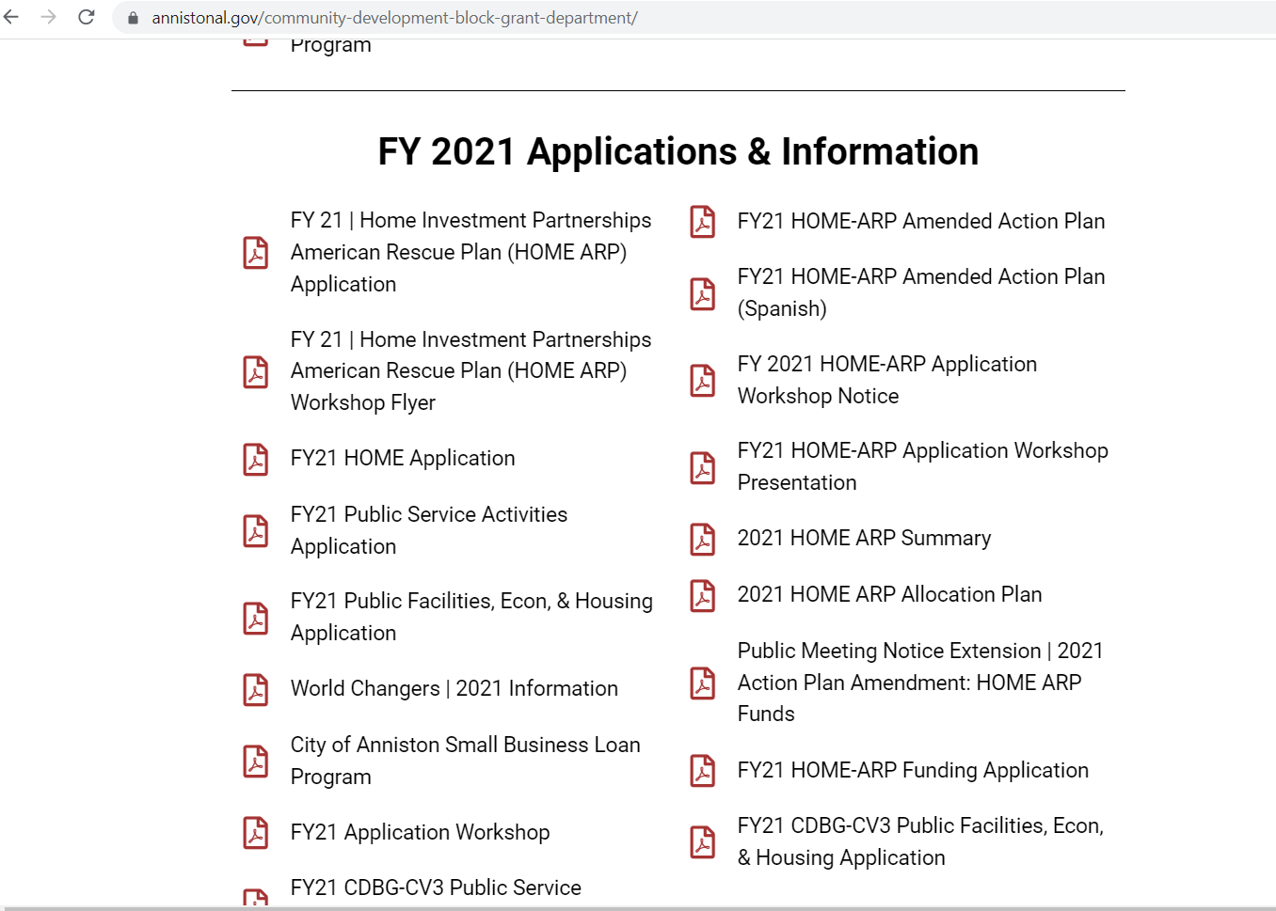

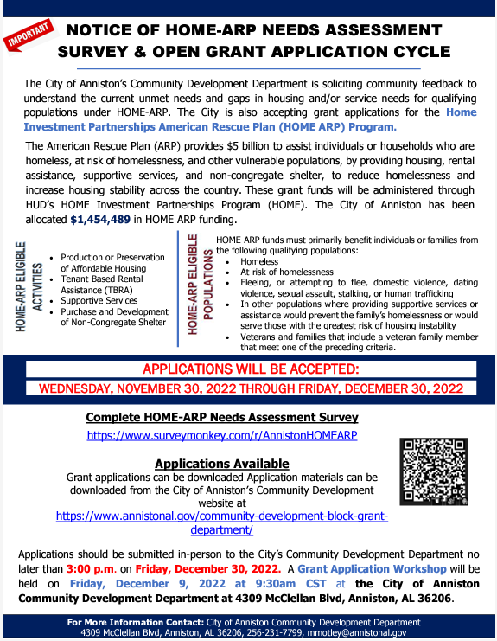
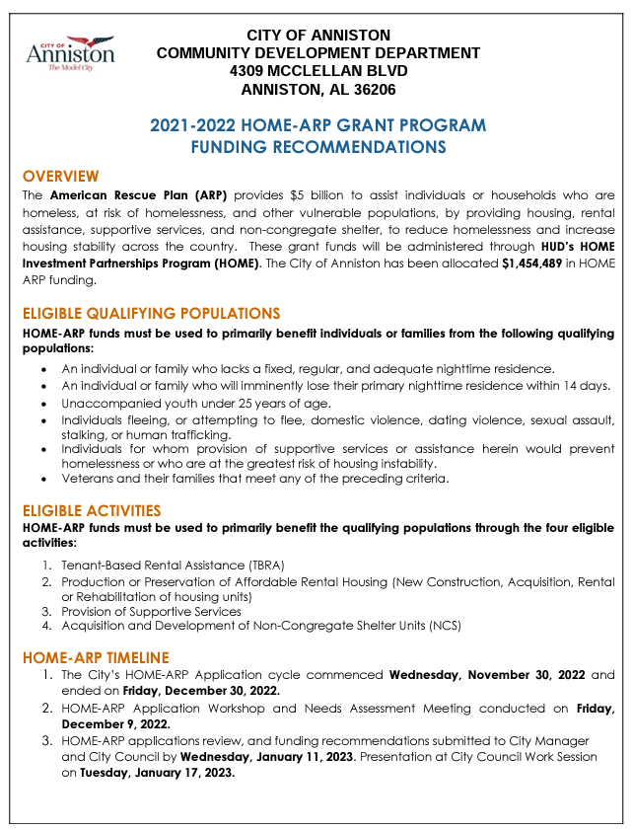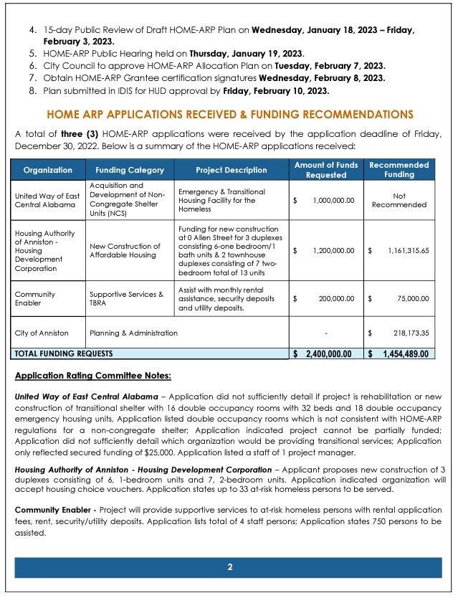

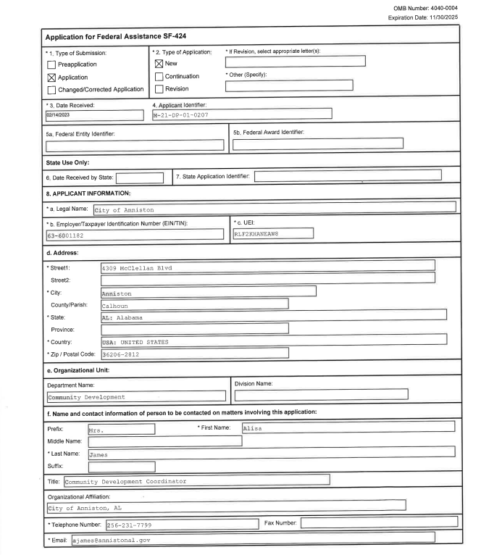
CERTIFICATIONS

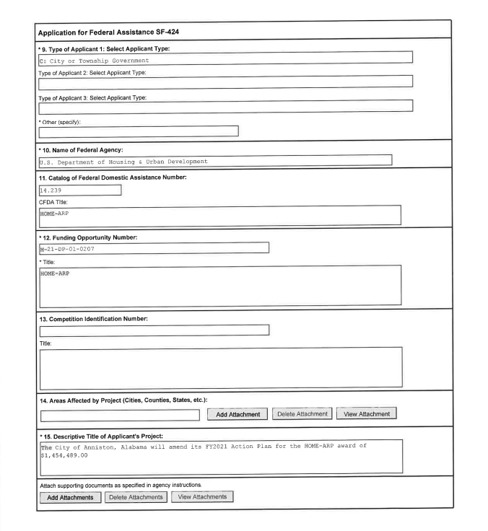

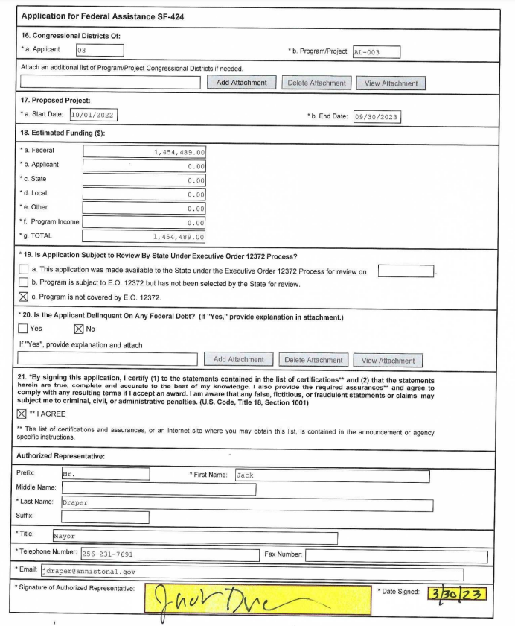
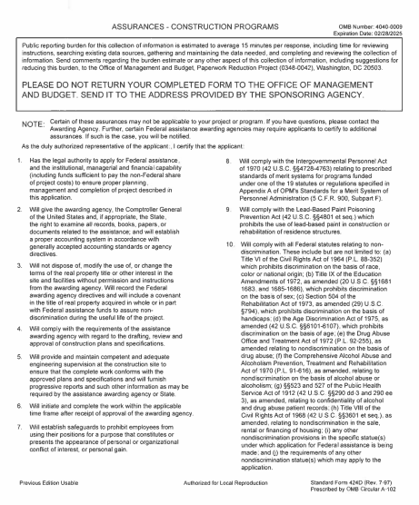

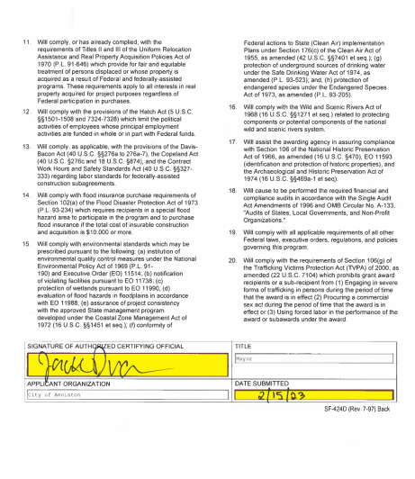
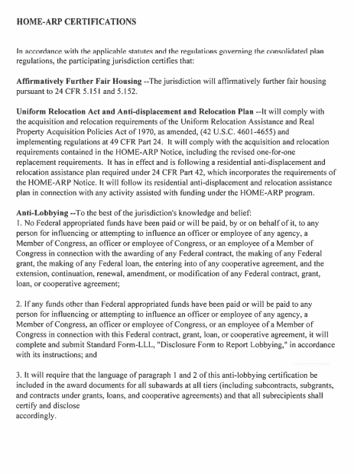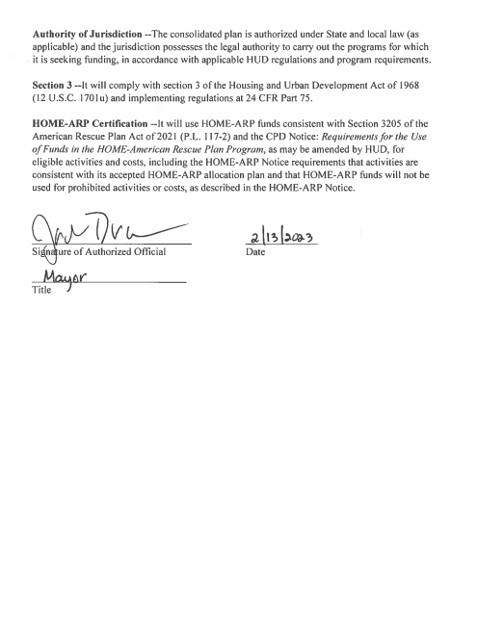

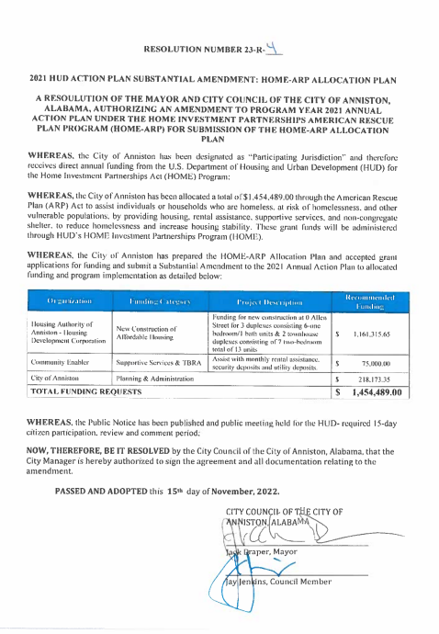

PUBLIC NOTICE

PUBLIC REVIEW MEETING NOTICE
2021 ACTION PLAN SECOND AMENDMENT: HOME-ARP ALLOCATION PLAN
PUBLICATION DATE: WEDNESDAY, JULY 2, 2025
PUBLIC COMMENTS DUE BY: FRIDAY, JULY 18, 2025 – 3:30 P.M.

The City of Anniston will hold a Public Review Meeting to solicit comments on the additional allocations and amended 2021 HOME Investment Partnerships American Rescue Plan (HOME-ARP) Allocation Plan at 10:00 A.M CST on Thursday, July 3, 2025 at the City of Anniston Community Development Department at 1129 Noble St, Anniston, AL 36201.

The City will accept comments on the additional allocations and amended 2021 HOME-ARP Allocation Plan commencing Wednesday, July 2, 2025 and ending on Friday, July 18, 2025, which represents the City’s 15-day public comment period. The City is required to develop a HOME-ARP Allocation Plan which displays the allocation of funding and preferences for eligible activities by the City and is submitted to the U.S. Department of Housing & Urban Development as a prerequisite to receiving funds for the HOME-ARP Program. A copy of the City of Anniston’s 2021 HOME-ARP Allocation Plan can be downloaded from the City’s website at: https://www.annistonal.gov/community-development-block-grant-department/. The City of Anniston has been allocated a total of $1,456,132.00 in HOME-ARP funding. Below is a list of the HOME-ARP Allocations:
HOME-APR FUNDING RECOMMENDATIONS
Organization | Funding Category | Project Description | INITIAL FUNDING RECOMMENDATIONS | FINAL RECOMMENDATIONS
Housing Authority of Anniston - Housing Development Corporation | New construction of Affordable Housing | Funding for new construction at 0 Allen Street for 3 duplexes consisting of 6-one bedroom/1 bath units & 2 townhouse duplexes consisting of 7-two bedroom total of 13 units | $ 1,161,315.65 | $ 1,161,315.65
Community Enabler | Supportive Services & TBRA | Assist with monthly rental assistance, security deposits and utility deposits. | $ 75,000.00 | $ 76,396.55
City of Anniston Admin/Planning – HOME-ARP | HOME-ARP Administration/Planning 10% | HOME-ARP Administration/Planning 10% | $ 218,173.35 | $ 218,419.80
TOTAL |  |  | $ 1,454,489.00 | $ 1,456,132.00
*Amended changes in red
This Notice will commence the City’s 15-day public comment period beginning on Wednesday, July 2, 2025 and ending on Friday, July 18, 2025. Please direct all comments/inquiries to: Written comments on the proposed reallocation of funding should be sent to City of Anniston Community Development Department at 1129 Noble St, Anniston, AL 36201 or via email at nwood@annistonal.gov.

AVISO PÚBLICO
AVISO DE REUNIÓN DE REVISIÓN PÚBLICA
SEGUNDA ENMIENDA DEL PLAN DE ACCIÓN 2021: PLAN DE ASIGNACIÓN DE HOME-ARP

FECHA DE PUBLICACIÓN: MIÉRCOLES, 2 DE JULIO DE 2025
FECHA LÍMITE PARA COMENTARIOS: VIERNES, 18 DE JULIO DE 2025, 15:30

La Ciudad de Anniston llevará a cabo una Reunión de Revisión Pública para solicitar comentarios sobre las asignaciones adicionales y el Plan de Asignación del Plan de Rescate Estadounidense de HOME Investment Partnerships (HOME-ARP) 2021 modificado a las 10:00 a.m. CST el jueves 3 de julio de 2025 en el Departamento de Desarrollo Comunitario de la Ciudad de Anniston en 1129 Noble St, Anniston, AL 36201.
La Ciudad aceptará comentarios sobre las asignaciones adicionales y el Plan de Asignación HOME-ARP 2021 modificado, a partir del miércoles 2 de julio de 2025 y hasta el viernes 18 de julio de 2025, lo que representa el período de 15 días para comentarios públicos. La Ciudad debe desarrollar un Plan de Asignación HOME-ARP que muestre la asignación de fondos y las preferencias para las actividades elegibles, y que se presente al Departamento de Vivienda y Desarrollo Urbano de los Estados Unidos como requisito previo para recibir fondos del Programa HOME-ARP. Puede descargar una copia del Plan de Asignación HOME-ARP 2021 de la Ciudad de Anniston desde el sitio web de la Ciudad: https://www.annistonal.gov/community-development-block-grant-department/. La Ciudad de Anniston ha recibido un total de $1,456,132.00 en fondos HOME-ARP. A continuación, se muestra una lista de las asignaciones de HOME-ARP:
RECOMENDACIONES DE FINANCIAMIENTO DE HOME-APR
Organización | Categoría de financiación | Descripción del proyecto | Recomendaciones de financiación
Housing Authority of Anniston - Housing Development Corporation | Nueva construcción de viviendas asequibles | Financiación para la nueva construcción en 0 Allen Street de 3 dúplex que constan de 6 unidades de un dormitorio y un baño y 2 dúplex adosados que constan de 7 unidades de dos dormitorios, con un total de 13 unidades. | $1,161,315.65
Community Enabler | Servicios de apoyo y TBRA | Ayudar con la ayuda mensual para el alquiler, los depósitos de seguridad y los depósitos de servicios públicos. | $76,396.55
City of Anniston Admin/Planning – HOME-ARP | HOME-ARP Administración/Planificación |  | $218,419.80
TOTAL |  |  | $1,456,132.00
*Cambios modificados en rojo
Este Aviso iniciará el período de comentarios públicos de 15 días de la Ciudad, que comienza el miércoles 2 de julio de 2025 y finaliza el viernes 18 de julio de 2025. Por favor, dirija todos sus comentarios o consultas a: Los comentarios por escrito sobre la reasignación propuesta de fondos deben enviarse al Departamento de Desarrollo Comunitario de la Ciudad de Anniston, ubicado en 1129 Noble St, Anniston, AL 36201, o por correo electrónico a nwood@annistonal.gov.
No se producirá desplazamiento alguno como resultado de las actividades descritas en este documento. En caso de desplazamiento, la Ciudad de Anniston implementará las disposiciones del CFR 570.606 (Asistencia Residencial Antidesplazamiento y Reubicación). La Ciudad de Anniston no discrimina por motivos de discapacidad en la admisión, el acceso, el tratamiento ni el empleo en los programas y actividades descritos en este documento. Hay un intérprete disponible, previa solicitud, para ayudar a las personas con dominio limitado del inglés. Cualquier solicitud de adaptación razonable que necesite una persona para participar plenamente en las reuniones, programas o actividades abiertas del Departamento de Desarrollo Comunitario de la Ciudad de Anniston debe dirigirse a: Sra. Nikita Wood, Coordinadora de Desarrollo Comunitario, (256) 231-7623 o nwood@annistonal.gov.

